Internship Opportunity
Are you a Grade 12 student interested in making new friends and getting to know some extrodinary individuals?
Then this is the internship opportunity for you.
We are looking for grade 12 students who are interested in learning about developmental disabilities. Includes online educational modules and 20-60 hours of support in an adult day health program. Where you will shadow a direct support professional.

Goals and Outcomes for the Intern:
- Learn about different developmental disabilities, communication techniques (Visual aids, Sign language, Non-verbal behavior), issues and roadblocks that individuals who have a developmental disability face
- Learn how to modify an activity and implement 1 activity in (art, music, physical exercise, self-advocacy, or another area of participant interest)
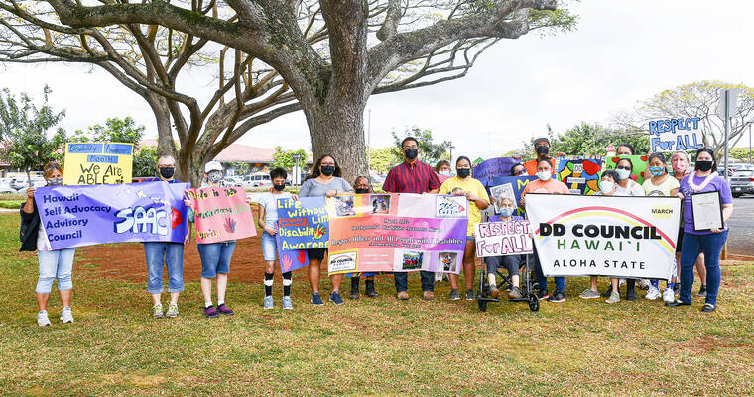
- Learn about self-advocacy and Developmental Disability Awareness Month
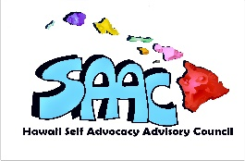
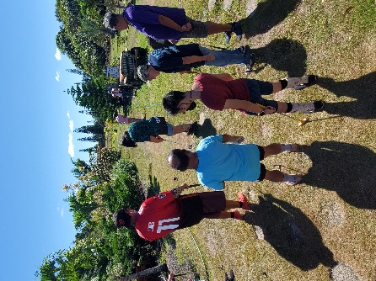
For more information please contact:
Amelia Kyewich-Kaneholani, Kauai Program Specialist for the Hawaii State Council on Developmental Disabilities at amelia.kyewich-kaneholani@doh.hawaii.gov or contact your student placement coordinator Ms. Keplar.

