|  |  |  |
| --- | --- | --- |
| Participants attending Senate floor session.  Meet your legislators!  Individuals with intellectual & developmental disabilities and family members take the opportunity to discuss disability-related issues and concerns with legislators and network with other concerned citizens.  A Day at the Capitol  Thursday, March 5, 2020  State Capitol Auditorium  Chamber Level  9:00 a.m. – 3:00 p.m. |  | Participants unite with one voice at the State Capitol.  The Issues  Advocacy  Dental  Early Intervention  Education  Emergency Preparedness  Employment  Health Care  Housing  Self-determination  Transportation  *We Celebrate*  Developmental Disabilities Awareness Month in March! |

Hawaii State Council on Developmental Disabilities *presents*

**registration**

DEADLINE: Registration forms must be submitted no later than Wednesday, February 5, 2020. Registration forms received after the deadline may not assure requests for lunch or accommodations will be met.

**scholarships**

Limited air & ground transportation scholarships are available for Neighbor Island participants.

**for registration forms, more information and questions:**

Oahu residents call the DD Council Office at (808) 586-8100

Neighbor Island residents call the following DD Council Staff: Hawaii Island: Jesse Floyd at (808) 936-4061 Maui, Molokai, & Lanai: Roxann Kehus at (808) 984-8218 Kauai: Che Silvert at (808) 274-3484

Day’s Activities

Continental Breakfast

Welcome & Orientation

Meetings with Legislators

House & Senate Floor Sessions

Lunch

Legislative Hearings

Meetings with Legislators

PAR presentation

Statewide participants meeting at the State Capitol Auditorium.

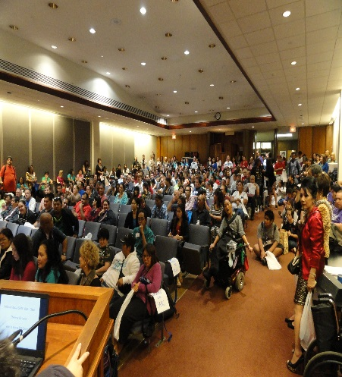

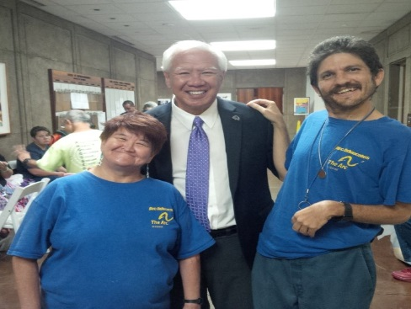

Pearl City self-advocates meet Representative Gregg Takayama.

*The Hawaii State Council on Developmental Disabilities is sponsoring this event in partnership with the Disability Communication Access Board, Hilopa’a Family to Family Health Information Center, Hawaii Waiver Providers Association, the Hawaii Self-Advocacy Advisory Council, and Maternal Child Health Leadership Education in Neurodevelopmental Disabilities.*





